The Documentation of the Export/Import Tool

## Tool Function Description

This tool is a plugin used with the “Revit” software. With this tool, it is able for users to export the building data of “Revit” model files to the SQL Server databases in the table format. Before exporting, users can view the data content in the interface. Meanwhile, the data stored in the database can be imported back to the corresponding “Revit” model file. On the other hand, this tool has a manage link function which can obtain all the model files of a project through the file links among them and the nested structure of the database is realized. Both the export and import processes do not require the activation of the target model file.

The data structure of the exported data in the database is designed as followed. A database represents a project, which contains all the building information of the project. Each model file in the project form a database schema in the database. Each “Category” of the model file is a table whose tuples are instances of the “Category” and columns are all possible parameters of the instances. (Figure 1-1)

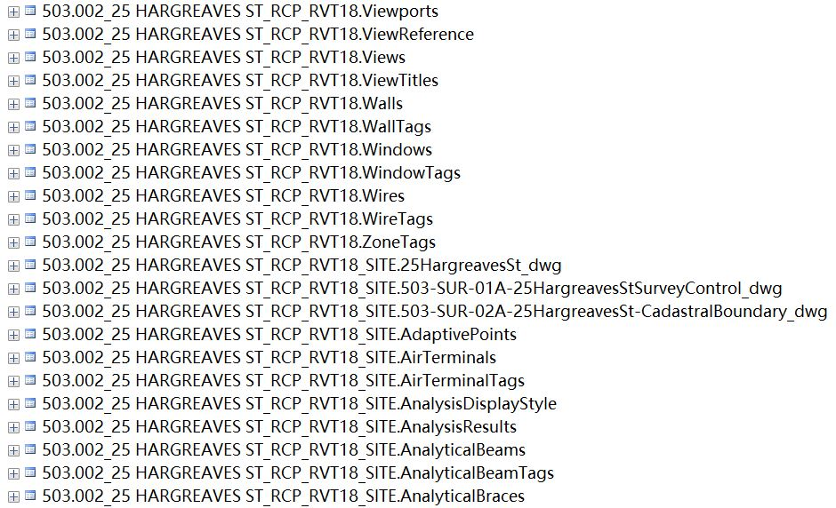

Figure 1-1 Schema and Tables in a Project Database

## Tool Preconfiguration

### Database Connection Customization

The default database connection information is based on the “AsBuilt” server. If there are requirements to make some modifications to the database connection information, it is necessary to customize the database connection string in the “DatabaseConnectionString()” of the “ExportFunctionForm.cs” and the “connectDatabase” string attribute in “Import_Schema”. Required information includes the database driver, the server address, the user id, and the corresponding password.

### “DLL” File Path Configuration

In “ExternalApplicationClass.cs”, the “thisAssemblyPath” attribute should be modified to an active path to the “Export_Import_Tool.dll” file. And the path of the icon image also should be active, which is the “uriImage” attribute.

### “ADDIN” files Configuration

In the folder of the “Export_Import_Tool”, there are two “ADDIN” files which are “Export_Import_Tool.addin” and “Export_Import_Tool_2.addin”. It is necessary to modify the content of the “Assembly” tag with the absolute path to the “Export_Import_Tool.dll” file.

After the modification, these two “ADDIN” files should be placed under the “AddIns” folder whose path is “C:\ProgramData\Autodesk\Revit\2018\Addins\”.

The “ADDIN” files make the program active as a plugin working with “Revit” software.

## Tool Instruction

There are two methods to invoke the tool after activating the “Revit” software. One is to invoke the plugin through the external tool (Figure 3-1), the other is pressing the icon in the tool bar (Figure 3-2).

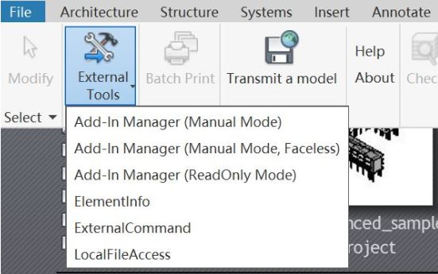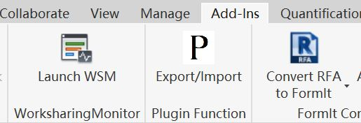Figure 3-1 External Tool Invoke Figure 3-2 The Icon Invoke

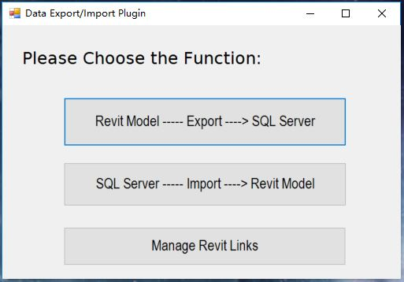

Figure 3-3 The Function Selection Page

Figure 3-3 shows the first page of this tool which is the function selection page. In this page, users can select their desired function. The top button can invoke the export function UI which is used to export the building data of model files or tables of a model to an existing project database. The middle button can invoke the import function UI. And the bottom button can invoke the manage link function UI whose consequences will be used to export a complete project database.

### Export a Complete Project

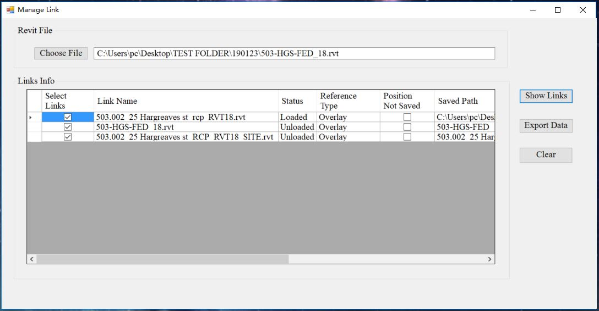

Figure 3-4 The Manage Link Function UI

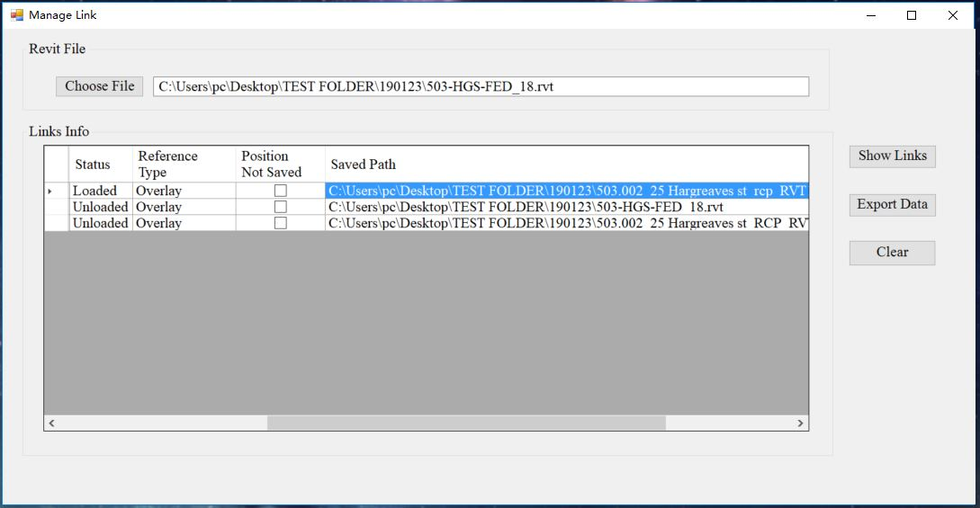

Figure 3-5 The Manage Link Function UI (Path Selection)

Figure 3-4 is the manage link function UI whose viewer can display the information of file links. The manage link function can obtain all the model files in the same project. Only through the manage link function, the completeness of the project database can be guaranteed. At first, it is essential to select a “Revit” model file in the desired project through the “Choose File” button. Then, all achievable file links will be displayed in the viewer after pressing the “Show Links” button. It is common that some file links exist but their statuses are “Unloaded” and their file paths are absent. Towards this issue, the tool allows users to select the file path manually through clicking the corresponding cell (Figure 3-5). If the selected path is correct and active, the program will automatically continue the model file search. If the model file of the found file link has not been shown in the viewer yet, the file link information will be added to the viewer. When there is no new file link can be added to the viewer, it is able to press the “Export Data” button to invoke the export function UI of the complete project export version with the found model files.

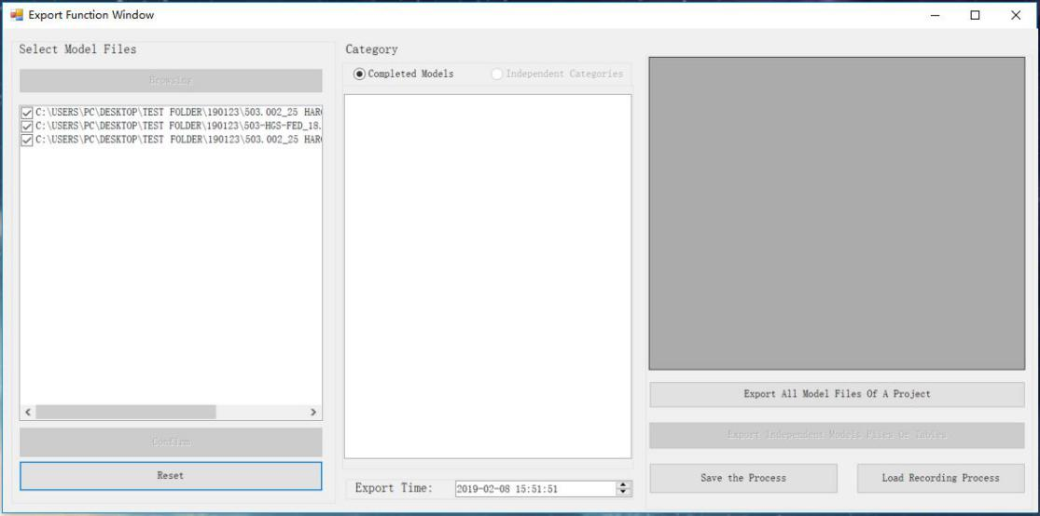

Figure 3-6 The Export Function UI (Complete Project Export Version)

Figure 3-6 is the export function UI of the complete project export version. The files obtained by the manage link function is added to the “Check List Box” on the left and only the complete project export button is enabled. After pressing the button, the program will check the existence of the project database through the comparison of the model file names and the schema names in the server. A database will be created if the matching is failed and the export process will start after that (Initial Project Export). If the database exists, an update process (Project Update Export) on the whole database will be executed and all the differences will be recorded in an “HTML” log file.

### Export Part of the Project

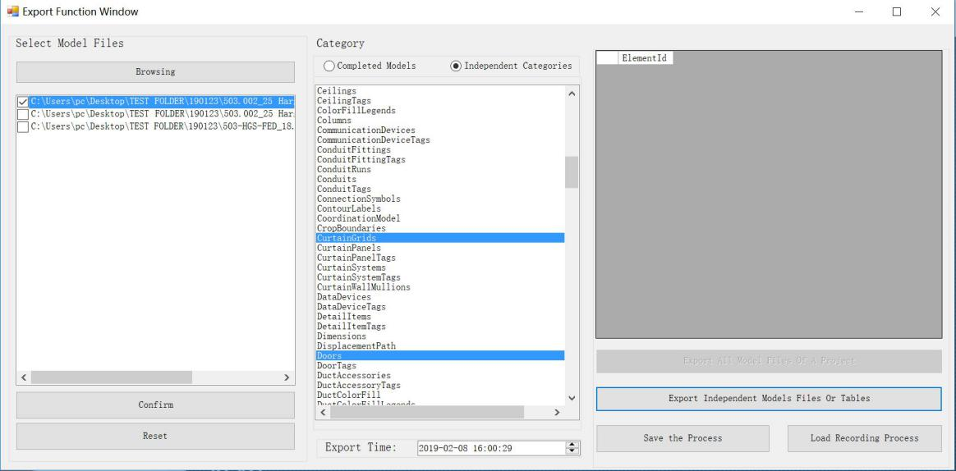

Figure 3-7 The Export Function UI (Partial Project Export Version)

Figure 3-7 is the export function UI of the partial project export version, which can be directly invoked through pressing the top button in the function selection page and only the “Partial Project Export” button is enabled. The middle radio button determine whether to export complete model files (Model Update Export) or just several tables of a model (Table Update Export). For complete model files export, the checked files on the left will be exported. In contrast, for tables export, the selected category of the selected file will be exported. It should be noticed that the partial project export will be failed if there is no corresponding project database in the server. For the reason that the partial project export is a kind of update process, an “HTML” file recording the differences between the old version and the new version of the database will be generated for each partial project export.

### View the Table Content

For every version of export function UI, from left to right, users can select the model file, the category, and view desired content in the viewer in the table format (Figure 3-8). The content displayed in the viewer is exactly what the data looks like in the database after the export.

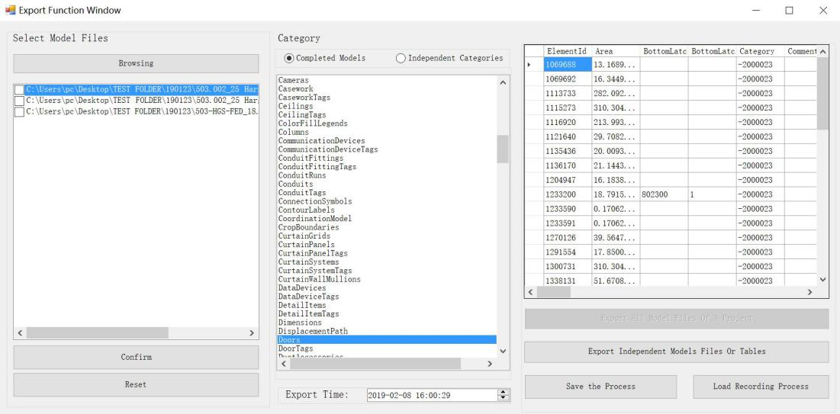

Figure 3-8 View the Content

### Additional Function of Export Function

1. Export Time Selection Function

All the export processes support that start export process at a specific time. It is realized through the date time picker at the bottom of the export function UI. If the selected time is earlier than the current time, the export process will start immediately. If there is still some time before the setting time, a waiting form displaying the setting time and the current time will pop up (Figure 3-9). And the “Cancel Export” button can dispose the form and cancel the export process.

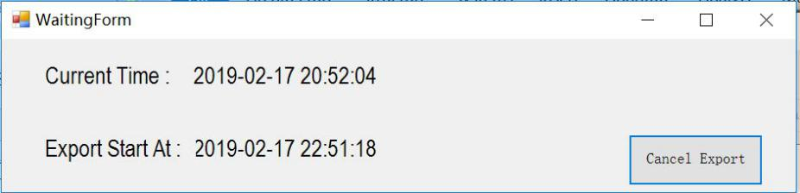

Figure 3-9 The Waiting Form

1. Export Process Simplification Function

In addition, The combination of the two buttons simplify the whole export process and there is no need to repeat the same operation to configure the export conditions. The “Save the Process” button can record necessary information of an export process to a “TXT” recording file if the information is adequate and the “Load Recording Process” button can read the recording file and reproduce the export conditions.

1. Log File Generation Function

Furthermore, for each export process, a “TXT” log file recording all the operations during the process will be generated. This file is used to check the reason if there is an error. And an “HTML” log file recording the differences between the old version and the new version of the databases is generated for each successful update process.

### Import Function

The import function UI which is displayed in Figure 3-10 can be directly invoked by pressing the middle button in the function selection page. Users can select the target model files with the “Add Model” button and the selected model files will be displayed in the up left “Check List Box”. When the “Confirm” button is pressed, corresponding databases and schema could be obtained in the lower window in the tree structure if the corresponding content exists in the database. And the content of selected table can be viewed in the viewer on the right. Through selecting corresponding tables, schema, and databases in the lower window and pressing the import button, it is able to import the content in the database back to corresponding model files.

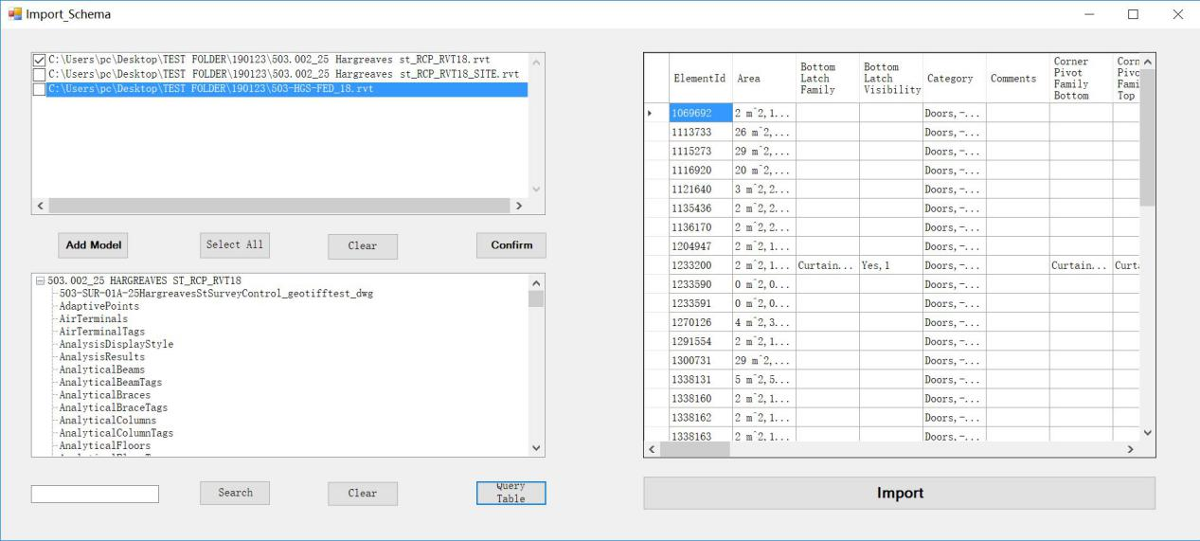

Figure 3-10 Import Function UI